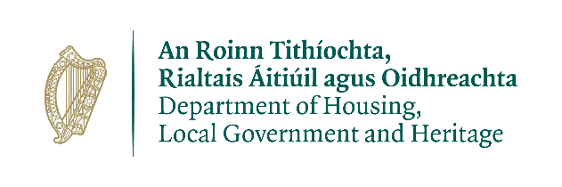
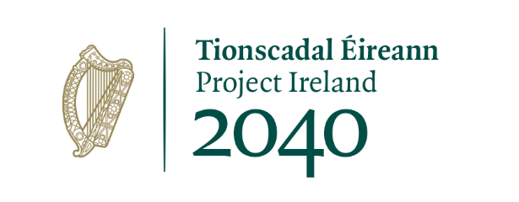

Monday 15 March 2021

Urban Regeneration and Development Fund ‘Call 2’
- €30.4 million Mid-East Projects

Kildare County Council project
Celbridge to Hazelhatch Link Road - €10.24 million
This project provides essential infrastructure to support compact consolidated development in Celbridge by realising the full potential of zoned lands south and east of the River Liffey. It will facilitate the delivery of social infrastructure in close proximity to the town centre, public transport services, schools, community facilities and employment hubs. It will also support wider strategic impacts on the public realm and the expansion and development potential of the town centre.
This project is the follow-on capital element to the successful URDF ‘Call 1’-funded project, which provided technical support for the comprehensive and integrated advancement of the Celbridge to Hazelhatch Link Road, a project identified for its positive wider impacts to its adjoining settlement surrounds.
The project switches the focus of social infrastructure development from the north to the south side of Celbridge to capitalise on the extent of public transport infrastructure there, with a particular focus on social infrastructure in the vicinity of Hazelhatch train station, while promoting the concepts of liveable compactness.
The project will also support national sustainable mobility principles by enhancing connectivity between Celbridge Town and Hazelhatch train station. It will provide high-quality walking and cycling linkages from residential areas to employment areas and public transport services, thereby increasing permeability and sustainable mobility within the area more generally.
Works to this project will include:
- Phases 3-7 of the Celbridge to Hazelhatch Link Road Scheme.
- Delivery of a second bridge over the River Liffey to access ‘Key Development Areas’.

Naas Town Renewal Masterplan - €3.5 million
The project will support the preparation of a Naas Town Renewal Masterplan for the historic core of Naas. The aim is to initiate the transformative regeneration of the town centre through a plan-led, evidence-based, urban design and economic focused approach.
The works to be supported include:
- Naas Town Renewal – preparation of a master plan
- Background Assessments - Feasibility Study for The Castle Quarter, and a conservation management plan and archaeological survey for St. David’s Castle and grounds
- Site assembly of key sites within the town centre
- Transportation Interventions – progression of these works to planning and detailed design stage

Maynooth Town Centre Renewal – Strengthening the Grid - €1.91 million
This project will support the preparation of a Master Plan. The plan will be informed by an urban design analysis and extensive stakeholder and public consultation. It will aim to maximise the development potential for the urban block structure and prepare key town renewal projects so as to increase town centre living.
Works under this ‘Call 2’ project include:
- ‘Maynooth Town Centre Renewal – Strengthening the Grid’ – Preparation of Masterplan
- District Heating Exploration Project – to determine the potential for a district heating scheme serving the commercial and residential community
- Development of key town renewal projects – these will be identified in the Master Plan
- Harbourfield Park - the development to detail design and tender stage

URDF funding for Kildare:
The €15.64 million in approved funding is in addition to €5.53 million in approved funding for the ‘Call 1’ project, ‘Letterkenny 2040’.
Total URDF funding approved to date: €21.17 million

Meath County Council projects
Flowerhill and Abbeylands Regeneration - €7.66 million
This is a public realm, amenity enhancements project with one historic refurbishment. It will be the catalyst for development within an area of decline and dereliction that was a hive of activity in the past. The aim is to address the impediments to redevelopment and regeneration by implementing the actions contained in the development framework produced through the successful URDF-funded ‘Call 1’ project. The works include:
- Streetscape Enhancement - strategic public amenity enhancement will include upgraded surface paving, new pedestrian crossings, cycle lanes, street trees, lighting and furniture
- River Park - strategic public amenity enhancement connecting to a wider greenway network. Works will include planting as well as pedestrian and cycle paths with associated lighting, furniture and wayfinding measures on the northern side of the River Blackwater
- Community, Cultural and Educational Facility - social infrastructure for the local community located within a restored building
- Frontage Improvement - works will involve the restoration and lighting of historic frontages to highlight Flower Hill’s built heritage

URDF funding for Meath:
The €7.66 million in approved funding is in addition to €10.32 million in approved URDF funding for four ‘Call 1’ projects: ‘Ashbourne Road and Public Realm Improvement’; ‘Flowerhill Regeneration Project’; ‘Navan Active Land Management Project’ and ‘Railway Street Regeneration and County Archive’.
Total URDF funding approved to date: €17.98 million

Wicklow County Council projects
Bray Harbour Area Integrated Regeneration - €7.14 million
This project focuses on the regeneration of the Bray Harbour Area and releasing various sites for future development through a series of integrated elements. The overall vision is to re-imagine and regenerate the strategically located waterfront area of Bray; to increase economic activity, amenity, and connectivity to public transport, the sea-front and esplanade. The aim is to deliver a vibrant public amenity that will be of great benefit to residents and visitors alike. Works envisaged include:
- Amenity and Public Realm – extension of amenity areas, improvement of streetscape, parking, cycle provision and sporting facilities
- Promenade Board Walk - linking the promenade with the harbour
- Cycle Bridge - to relieve a pinch point at the Dargle Bridge crossing
- Relocation of boat storage to the north of the harbour

URDF funding for Wicklow:
The €7.14 million in approved funding is in addition to €13.42 million in approved URDF funding for three ‘Call 1’ projects: ‘Bray Public Transport Bridge’; ‘Arklow Historic Town Core’; and ‘Wicklow Town’.
Total URDF funding approved to date: €20.56 million

Analysis of the Mid-East region’s needs
This region’s strategic location, proximate to the capital, has resulted in significant regional development characterised by the dominance of Dublin. However, the region is also characterised by a range of large towns. To support the ongoing development of the region, a more balanced and sustainable pattern of development is required. The focus of the approved URDF projects will go some way to addressing local infrastructure needs and the legacy of rapid growth.

Urban Regeneration and Development Fund
- The URDF is one of four funds established under the National Development Plan (NDP) 2018-2027. It has an allocation of €2 billion to 2027. Its aim is to support more compact and sustainable development in Ireland’s five cities and other large urban areas. Funding is aimed at projects that support the NDP objectives and the NPF’s ten ‘national strategic outcomes’, which include compact growth; enhanced regional accessibility; and sustainable mobility. The Department of Housing, Local Government and Heritage is responsible for administering the URDF.
The five chosen projects are consistent with the Eastern and Midlands Regional Assembly’s Regional Spatial and Economic Strategy, and where relevant, the Dublin Metropolitan Area Strategic Plan
- Through the URDF, successful applicants receive targeted, integrated funding for innovative solutions to issues that have hindered urban regeneration and rejuvenation. The fund part-funds projects that will deliver a greater proportion of residential and mixed-use development within the existing built-up footprints of cities and large towns.
- The URDF’s significant capital investment acts as a catalyst for wider regeneration, development and growth. The IDA has already acknowledged the URDF’s important role in creating a sense of place, something considered essential for increasing Ireland’s attractiveness to foreign investment and strengthening opportunities for indigenous enterprise.
- URDF ‘Call 1’ funding: The URDF is already providing assistance for major regeneration projects in Ireland’s larger urban areas. Under ‘Call 1’ of the URDF, 87 projects are being funded. Details were announced in November 2018. These projects are spread across the regions and span a number of the NPF’s objectives. The total provisional allocations to date in respect of these 87 projects is just under €300m.
- URDF ‘Call 2’ funding: a second call for funding proposals was announced in January 2020. It focused on (1) integrated urban developments (2) strategic development areas combining a number of elements and (3) schemes that support wider climate action objectives and quality of life factors within cities and towns. Projects aim to deliver compact growth whilst ensuring more of our urban areas become attractive and vibrant places in which to live, work, visit and invest.
- More information on the URDF is available at: www.gov.ie/urdf

